How the data used to look (coming from an Adobe 5 document)

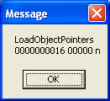

How the data looks when an Adobe 9 document is used

